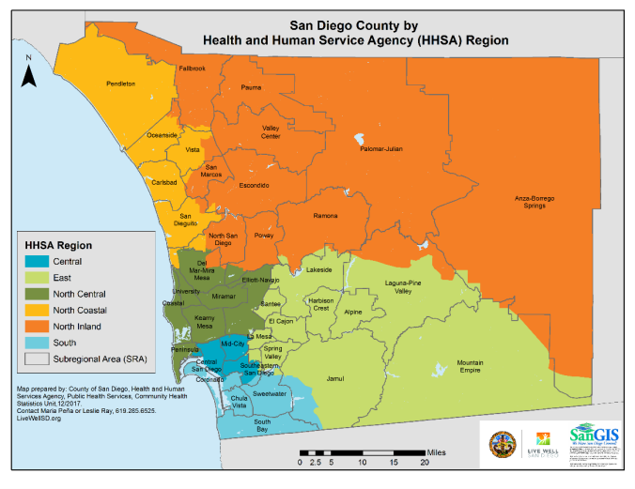

**Key Points:**

1. Cancer and heart diseases are the leading causes of deaths in San Diego County.
2. The Central and South regions take up 30% of San Diego County’s population, but face the most health disparities among all HHSA regions due to higher poverty and unemployment rates as well as lower education attainment. Chronic diseases such as heart disease, cancer, diabetes, and Alzheimer's disease and other dementias account for nearly half of deaths in those regions and have among the highest incidents among other regions.
3. The Central region is one of the most diverse regions in San Diego County, but faces health and socioeconomic disparities with lower access to healthcare services, lack of insurance, and transportation issues despite being geographically central.
4. The South region has a large population of Hispanics/Latinos and immigrants. Its location by the U.S.-Mexico borders creates challenges to access healthcare services due to the language barrier.

[**Central Region**](https://www.sandiegocounty.gov/content/dam/sdc/hhsa/programs/phs/CHS/Central%20Region%20CHA%20Presentation%202024.pdf)

* **Population:** 508,539 (updated 2022); 15.5% of San Diego County’s population
* **Geography:** San Diego Bay, downtown San Diego and outlying urban communities
* **Life Expectancy:** 79.8
* 1 in 7 Central Region residents self-reported their health status as fair/poor in 2022.
* The percentage of residents reporting good/very good health was similar in 2018 (60.8%) and 2022 (60.6%).
* All Central Region subregional areas (SRAs) had a decrease in life expectancy from 2018-2022.
* 1 in 3 Central Region residents were living below 200% FPL in 2022.
* In 2022, diseases of the heart were the number one leading cause of death in the Central Region, followed by cancer.
* Despite a decrease, chronic diseases still accounted for 45% of all deaths in the Central Region in 2022.

[**East**](https://www.sandiegocounty.gov/content/dam/sdc/hhsa/programs/phs/CHS/East%20Region%20CHA%20Presentation%202024_FINAL%2006.18.24.pdf)

* **Population:** 502,639 residents; 15.3% of San Diego County’s population
* **Geography:** second largest geographical area in the county; share an international border with Mexico; very diverse geographic region in the county, and includes vast valleys, arid landscapes, and mountainous terrain. It comprises incorporated and unincorporated areas, suburban and rural communities, and Indian reservations.
* **Life Expectancy:** 78.5
* Over 1 in 11 East Region residents (9.3%) self-reported their health status as fair or poor in 2022.
* East Region had the highest proportion of residents reporting a disability compared to other HHSA regions in 2022.
* Despite a decrease, chronic diseases accounted for 45% of all deaths in East Region in 2022.
* In 2022, East Region had a higher age-adjusted death rate due to Alzheimer’s Disease and Related Dementias (ADRD) than the county overall.
* In 2022, cancer was the number one leading cause of death in East Region.

[**North Central**](https://www.sandiegocounty.gov/content/dam/sdc/hhsa/programs/phs/CHS/North%20Central%20Region%20CHA%20Presentation%202024_Final.pdf)

* **Population:** 642,507 residents; 19.5% of San Diego County’s population
* **Geography:** One of the most diverse geographical regions in the county, including miles of pristine pacific coastline, steep canyons, valleys, and mountainous terrains; comprised of coastal towns, university communities, suburban areas, and military facilities
* **Life Expectancy:** 85.3
* In 2022, cancer (malignant neoplasms) and heart disease were the cause of 42.2% of the deaths among North Central Region residents.

[**North Coastal**](https://www.sandiegocounty.gov/content/dam/sdc/hhsa/programs/phs/CHS/North%20County%20CHA%20Presentation%202024_FINAL.pdf)

* **Population:** 532,546; 16.2% of San Diego County’s population
* **Geography:** coastal
* **Life Expectancy:** 81.4
* In 2022, cancer was the number one leading cause of death in North Coastal Region, followed by diseases of the heart.
* Of the 15 leading causes of death in North Coastal Region, 9 were due to chronic disease.
* Vista and Oceanside SRAs faced disproportionate rates of chronic diseases compared to other North Coastal Region SRAs from 2018 to 2022.

[**North Inland**](https://www.sandiegocounty.gov/content/dam/sdc/hhsa/programs/phs/CHS/North%20County%20CHA%20Presentation%202024_FINAL.pdf)

* **Population:** 606,857; 18.4% of San Diego County’s population
* **Geography:** suburban areas, remote desert communities, historic mountain towns, rural homes and farms, and Indian reservations
* **Life Expectancy:** 79.7
* In 2022, cancer was the number one leading cause of death in North Inland Region, followed by diseases of the heart.
* Of the 15 leading causes of death in North Inland Region, 9 were due to chronic disease.

[**South**](https://www.sandiegocounty.gov/content/dam/sdc/hhsa/programs/phs/CHS/South%20Region%20CHA%20Presentation%202024_FINAL.pdf)

* **Population:** 496,613 residents; 15.1% of San Diego County’s total population in 2022
* **Geography:** highly diverse border region, covering 155 square miles of urban, suburban, and rural areas
* **Life Expectancy: 80.0**
* Compared to other HHSA Regions, South Region had the lowest proportion of its population 5+ speaking English only at home in 2022.
* South Region had the lowest proportion of adults with income less than 200% FPL reporting food insecurity compared to all other HHSA Regions in San Diego County, on average between 2021 and 2022.
* Over 1 in 4 South Region residents were living below 200% FPL in 2022.
* South Region had the highest 5-year average unemployment percent among the HHSA Regions for 2017 and 2022.
* South Region had the highest proportion of adults without a high school diploma in 2017 and 2022 among the HHSA Regions.
* In 2022, cancer was the number one leading cause of death in South Region.
* In South Region, 8 out of the top 10 leading causes of death were due to chronic disease in 2022.
* South Region had disproportionate rates of ED discharge and hospitalization due to chronic diseases compared to all other HHSA Regions in 2022.

*\*\*Note that some counties and SRAs within regions faced disproportionate rates of certain diseases.*